# SL4J Logging exercises

**Exercise 1: Logging Error Messages and Warning Levels**

Task: Write a Java application that demonstrates logging error messages and warning levels

using SLF4J.

**Step-by-Step Solution:**

* Click on **"New Project"**.
* Select **"Maven"** from the left menu.
* **GroupId:** com.example
* **ArtifactId:** logging-demo
* Click **Next**, then **Finish**.
* Open pom.xml in IntelliJ.

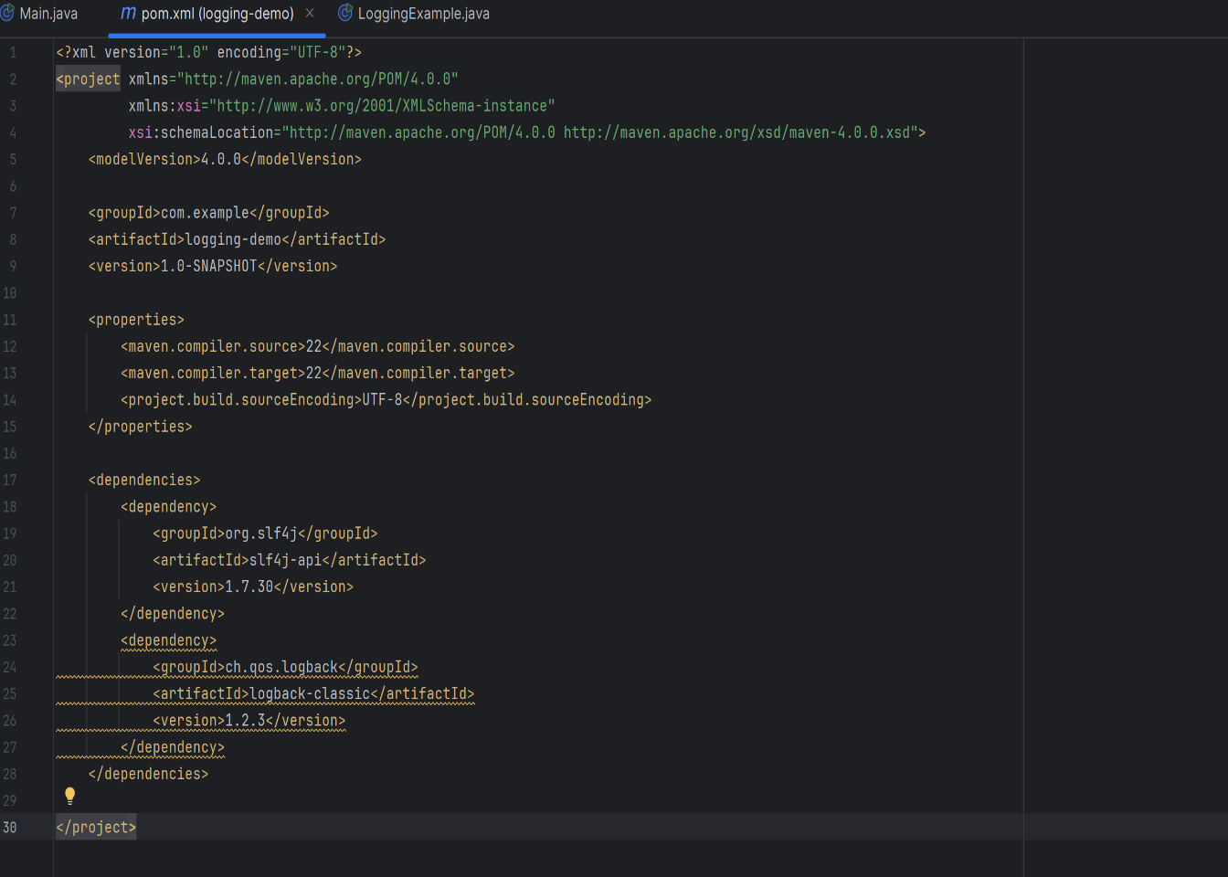

* Go to src/main/java.
* Right-click on the com.example package (or create one if it doesn’t exist).
* Choose **New → Java Class**.
* Name it LoggingExample.

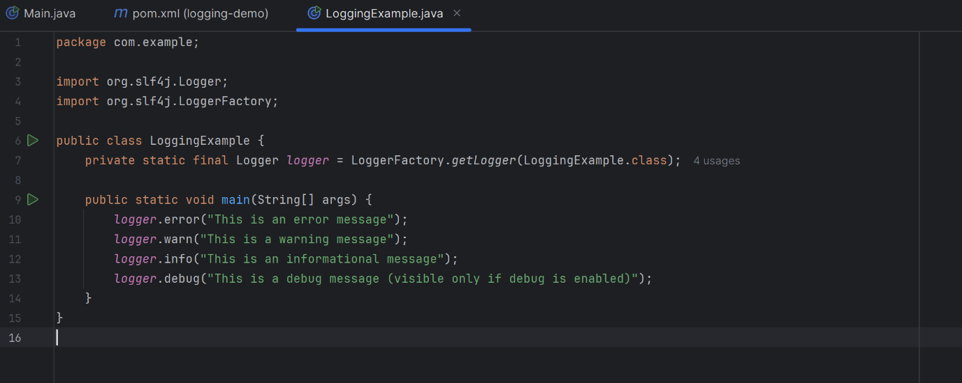

**OUTPUT**



